**10/06/2017**

**BBSG setup for Donport4**

# DATABASE SETUP

Download and install Navicat for MySQL, using my existing license.

For MySQL, download the complete MySQL installer, which will give you both MySQL server, and MySQL Developer (Workbench).

In MySQL57, make local schemas ltdv1 and ltprod by right-clicking in Navigator panel in the Schemas area, and selecting Create Schema.

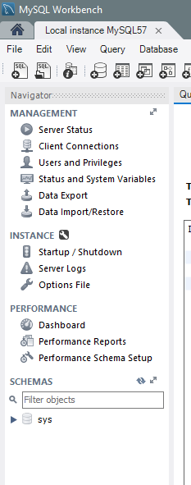

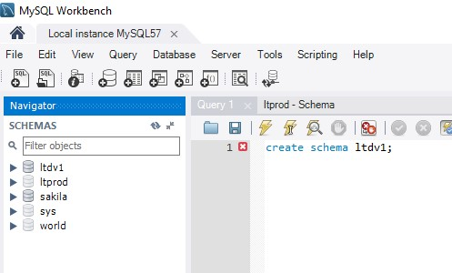

In MySQL Workbench, make local and remote connections, (e.g. Local Instance MySQL57, remote lttest1h). Start in MySQL Workbench by clicking DataBase, Manage Database Connections.

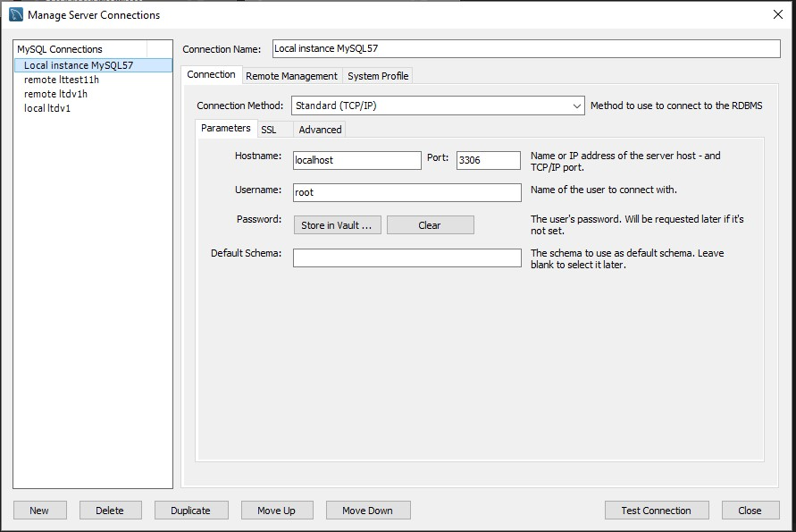

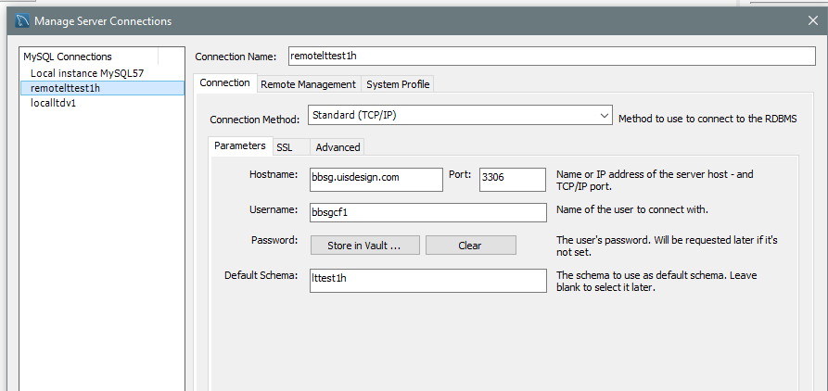

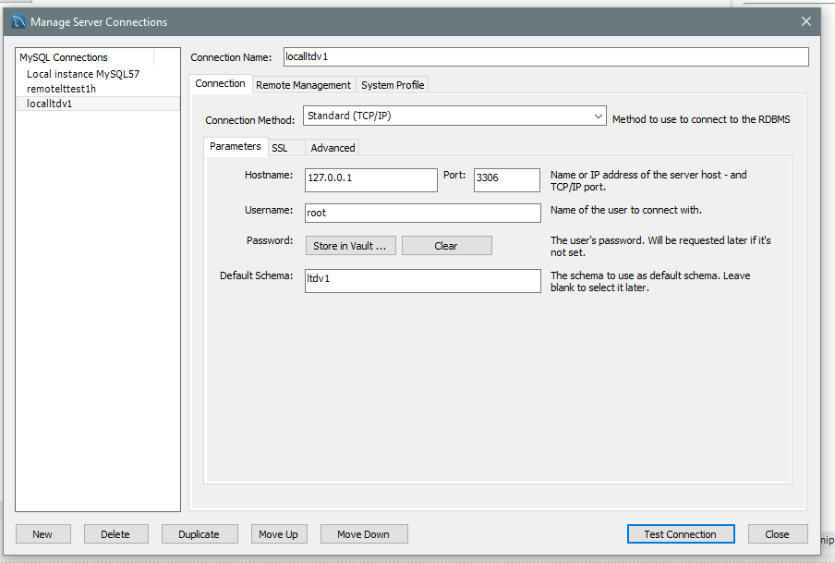

.

Then in Navicat, set up data connections. Start with File, New Connection.

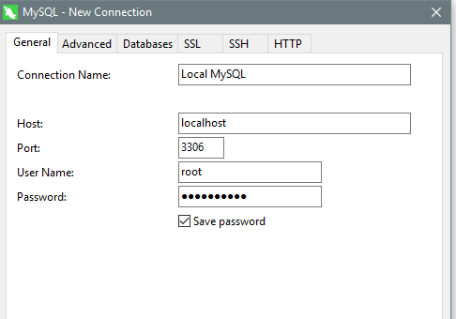

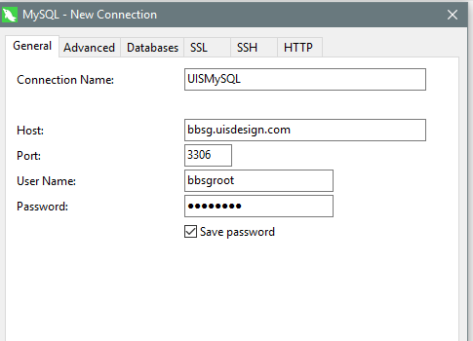

Set up a Data Transfer profile like remote lttest1h to local ltdv1, Load, and Start.

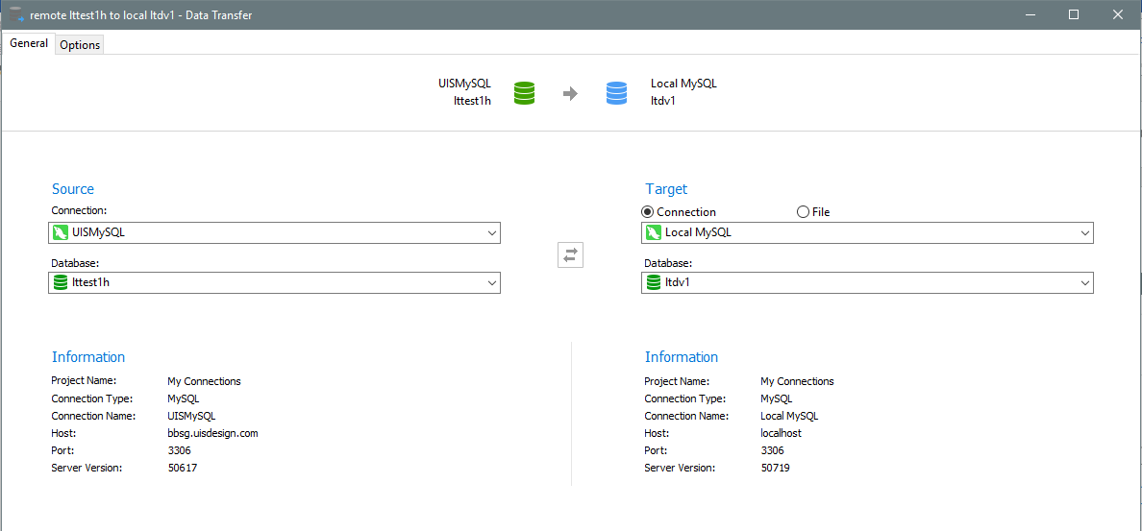

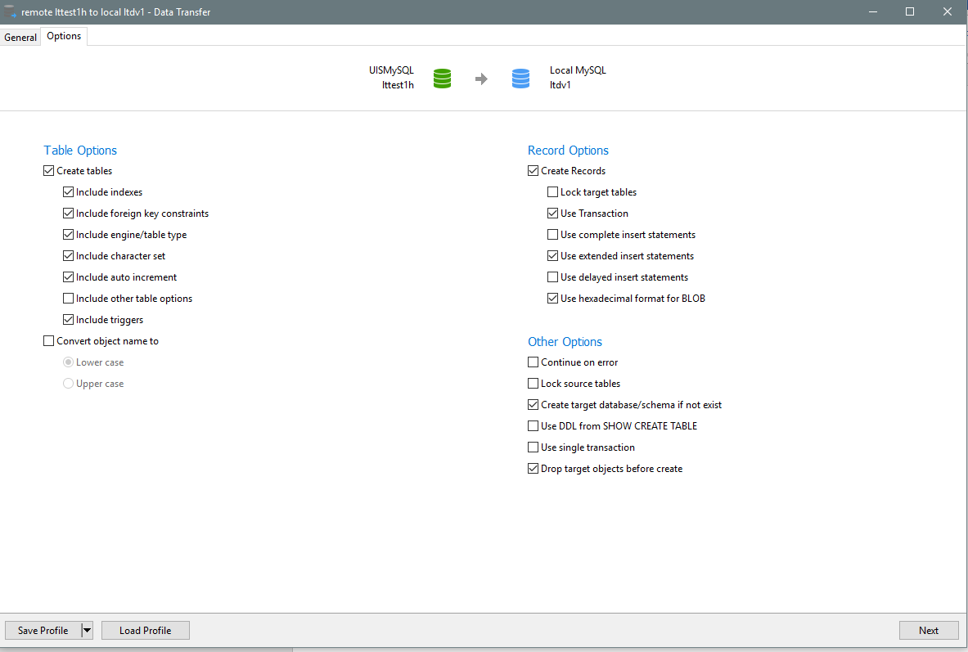

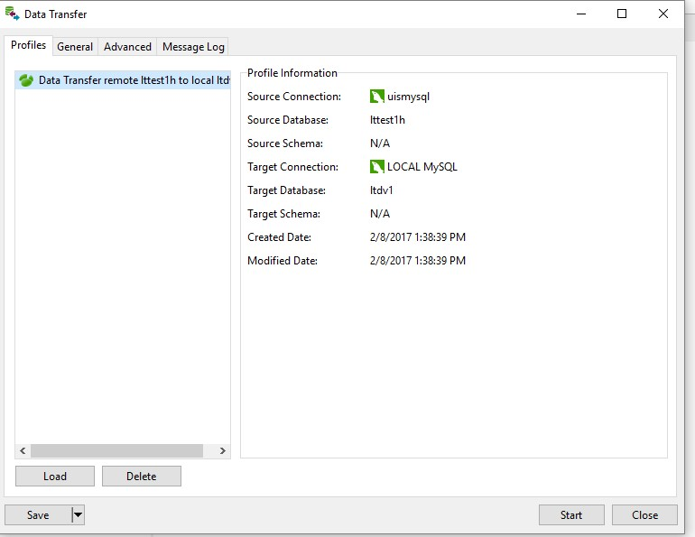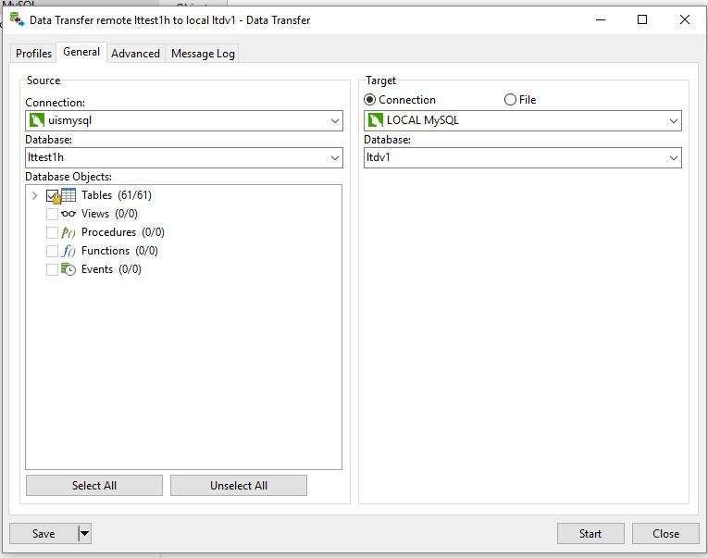

The result is the tables showing up in MySQL. Do File, New Query Window to have a workspace window.

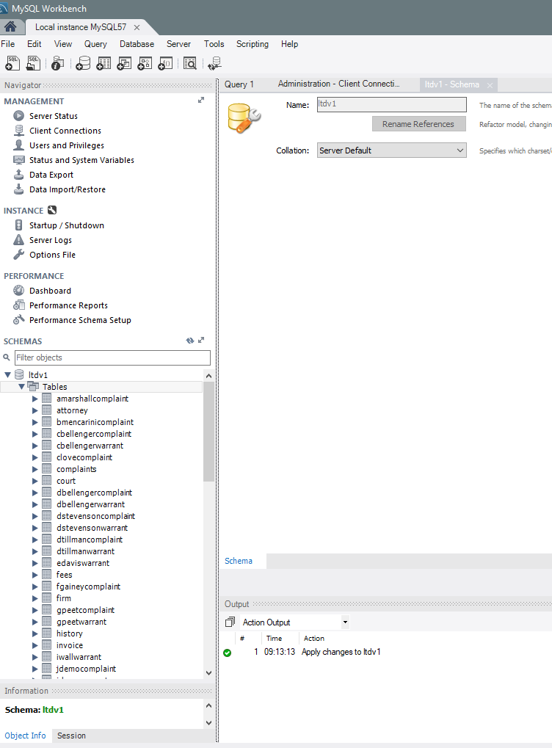

CODE/GIT SETUP

The code is in github in belldrfree. In this example, we are setting up a new branch: test, and putting the code into a new directory: C:\projects\cbsites\bbsgtest.

# ENVIRONMENT SETUP

Install command box (already done from DONPORT4, from George).

In this example we are setting up C:\projects\cbsites\bbsgtest

Make a **Powershell profile** in C:\Users\dbellenger\Documents\WindowsPowerShell\Microsoft.PowerShell_profile.ps1 using Sublime, or add this command to the existing profile:

function gobbsg { cd "C:\projects\cbsites bbsgtest"

box }

Use Sublime to make C:\projects\cbsites\ bbsgtest\go.boxr, containing

**server start** [**cfengine=lucee@5.2.3+35**](mailto:cfengine=lucee@5.2.3+35) **port=55088 name=bbsgdv1 –force**

This defines the LUCEE version, and port for the application. The port must be consistent with the port defined in config/coldbox.cfc for this environment (“localbbsgtest”)

You can use box interactively, as in

Server start cfengine=lucee@ <TAB>

To see what options are available for the cfengine for LUCEE.

Running the server start command above will result in a lucee error, since the data sources are not defined.

Once the server has been started, click on the icon in the Server tray for bbsgtest, and open server admin ( or navigate to http://127.0.0.1:55088/lucee/admin/server.cfm).

Here is Lucee Admin (Server, not web) (nutlist123):

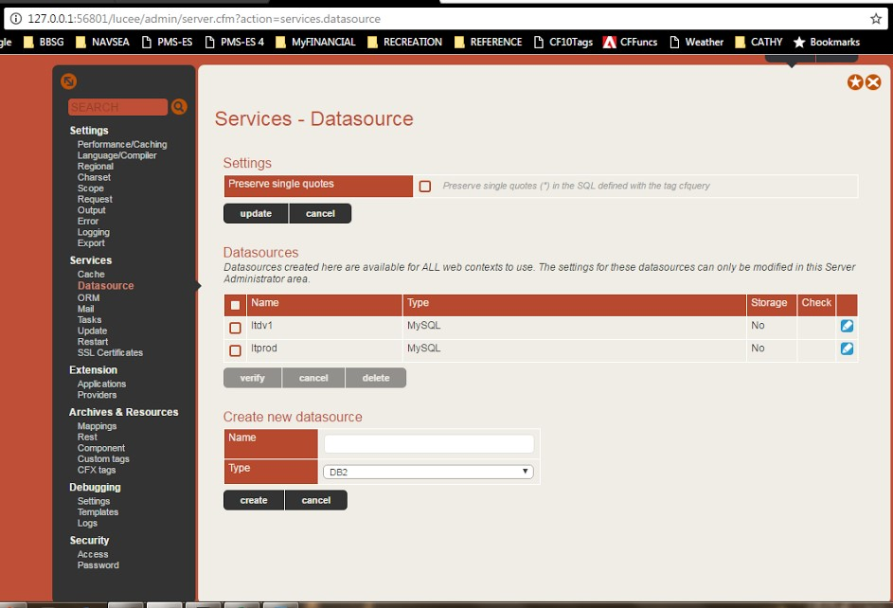

Details for local source.

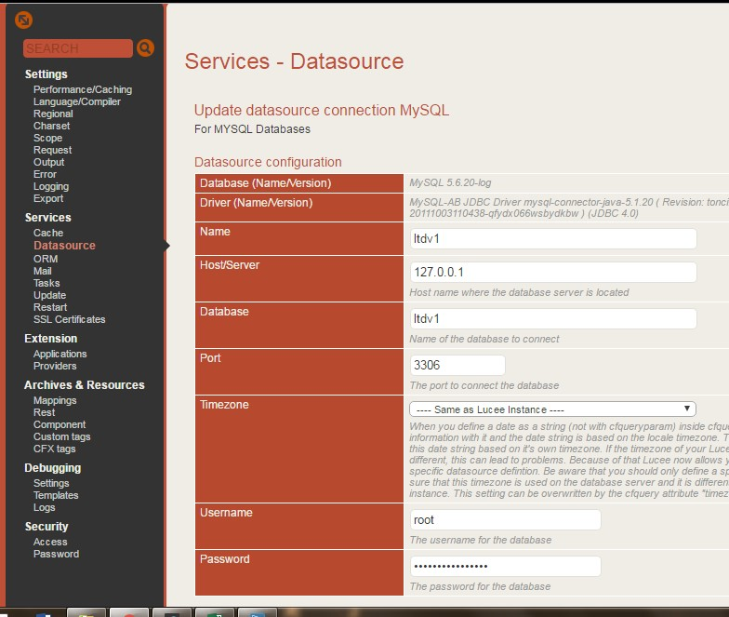

log in to the SERVER as root create the ltest datasource.

Link to start the bbsgtest application is

127.0.0.1:55088/index.cfm?fwreinit=nutbox